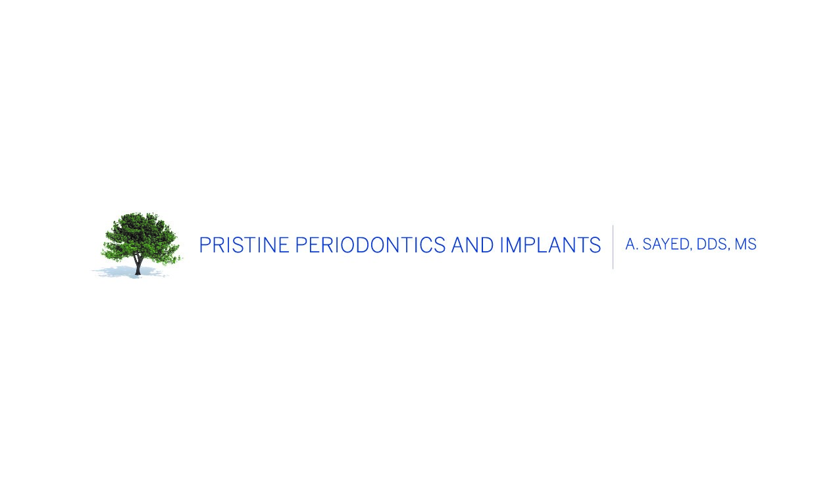
POST SCALING AND ROOT PLANING INSTRUCTIONS

IMMEDIATELY FOLLOWING THE PROCEDURE: Chances are when you leave our office you will still be numb. Refrain from eating anything until all numbness has worn off to avoid biting your lip, cheek, or tongue. However, to maintain adequate nutrition you may carefully eat soft foods (i.e. yogurt, apple sauce, oatmeal, jello, or foods that do not require chewing) or have a smoothie or protein before your mouth feels back to normal.

HOMECARE: A clean mouth heals faster! For optimal healing it is critical to continue excellent oral hygiene practices in all areas in your mouth low. Rest assured it is normal for teeth that have recently had scaling and root planing to be sensitive to hot and cold. If this occurs, try and continue brushing and flossing as much as possible and switch to using Sensodyne toothpaste.

MEDICATIONS: Take your prescriptions as instructed by your doctor. If at any time you develop a fever or a rash, contact us immediately.
• Mouthrinse: If a mouthrinse was prescribed, to get the maximum benefit of the rinse avoid eating or drinking anything for 30 minutes after rinsing. In addition, you may gently rinse your mouth with warm salt water (1/4 tsp. to 8 oz water) after each meal (*do not use salt water if you have high blood pressure).
• Pain medications: We recommend you take a Non-Steroidal Anti-Inflammatory Drug (such as Anaprox DS, Ibuprofen, Aleve, etc.) immediately following this procedure before the local anesthetic wears off. (*Unless you are allergic to such medications)

BLEEDING: After scaling and root planing, it is normal to have blood in your saliva. You may experience minor oozing for up to 48 hours after this procedure. However, if bleeding continues or becomes more profound, apply pressure in the area with damp gauze for 30 minutes. You may also substitute gauze with a warm, wetted tea bag as the tannic acid in tea may help stop the bleeding. If heavy bleeding persists, contact us immediately.

SMOKING: Smoking is detrimental to healing tissues and will negatively impact your results. If smoking cessation is not a realistic option for you, please refrain from smoking for at least 72 hours prior to and 3 weeks following this procedure as studies have shown that this will improve long-term results.

It is our sincere mission and desire that you are as comfortable as possible following this procedure. If you should have any problems or questions please call our office 248-901-0000. For after-hours emergencies please feel free to call your doctor on his personal cell:

Abbey Sayed: 248.763.9220

